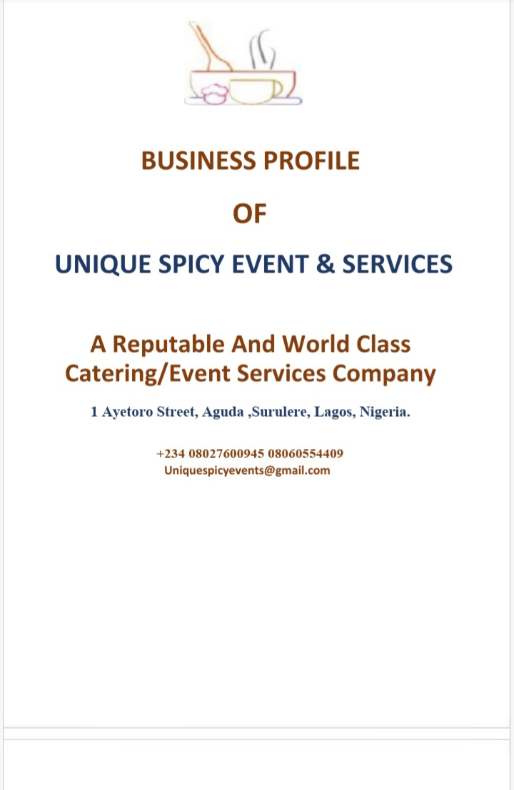 

**Mission**

Mission statement :

To provide the catering and event services that match customer demands at minimal cost .

**Vision**

Vision statement

We are willing to achieve quality in the delivery of all our services at pocket friendly cost.

**Core values:**

Affordability

Quality

Retainership

Improvement.

Professionalism

Variety

Excellent Presentation

Consistency.

Hygiene

|  |
| --- |
|  |

**OBJECTIVE**

1. To look for the best raw materials in the most hygienical places
2. To provide the most nutritional and nourishing foods such as local delicacies, continental, and oriental cuisine
3. To give you what you actually need at appropriate time
4. To exceed customer expectations by making your event and occasion glamourous and memorable.
5. To continue to improve our customers services delivery by reviewing customer feedbacks.
6. To continue to improve Unique spicy quality management system and process by continual internal audit and review our process to ensure compliance with statutory, Legal, regulatory and other convections observe in catering and event industry.

**COMPANY PROFILE**

Unique spicy is an indigenous catering and event company established in Lagos. We cater for most establishment in the environ for example APMT Apapa.

Unique spicy manages your event, meetings, conferences, occasions and canteens in the most efficient and affordable way, that will surpass your expectation.

Unique spicy provides all nourishment and colorful ambience , at your need , at affordable rate.

**WHAT DO WE OFFER?**

We offer Top notch services that you find below:

|  |  |  |  |
| --- | --- | --- | --- |
| **S/N** | **SERVICE DESCRIPTION** | **UNIT** | **PRICE**  **(#)** |
| **1** | **STANDARD LUNCH** | **PER MEAL** | **1000** |
| **2** | **STANDARD BREAKFAST** | **PER MEAL** | **700** |
| **3** | **MEETING/ CONFERANCE CATERING** | **PER MEAL** | **1500** |
| **4** | **EVENT MANAGEMENT** |  | **DEPEND OF NO OF PEOPLE AND VENUE** |

# .





### OUR MENU PROFILE

Looking through our menus, will help you make choices that suit your desires. We provide services that suit every individuals and corporate bodies, in any position, at any capacity.

#### 3.1. BREAKFAST DISHES / MEALS



* Ogi (Pap) (Fermented Cornmeal Porridge) - With Akara (Fried Black Eyed Bean Pancakes)/ Moi Moi (Steamed Black Eyed Bean Cakes) / Yoyo (Fried Whitebait) /Frejon

* Isu Bibo(Yam) With Ewa (Stewed Black Eyed Beans)
* Isu Bibo (Yam) With Obe (Shredded Beef / Chicken / Fish Stew)

* Adalu - (Stewed Black Eyed Beans & Sweet corn)
* Ogede Bibo(Steamed Plantain) Ati Isu Bibo (Boiled Yam) Pelu Obe (

Shredded Beef / Chicken / Fish Stew)

* Asaro - Steamed Yam Pottage
* Tapioca (Grated Cassava Granules With Milk And Cloves)

* Bread And African Egg Omelette /Fish / Chicken / Meat Stew /Ewa

Eko(Steamed Fermented Corn Cakes) And moimoi

* Custard (Processed Cornflower) /Semolina Pudding With Milk And Grilled Meat /Fish /Chicken

**SANDWISHES**

Queen Maker

Sunny Top Sides

Pouched egg sandwich

Beef Sandwich

**3.1.2 LUNCH DISHES/MEALS**

# STAPLES

Iyan (Pounded Yam/Eba (Steamed Roasted Fermented Cassava Flour) / Lafun (Steamed Fermented Cassava Flour) / Amala (Steamed Sundried

Yam Flour), / Fufu (Steamed Fermented Cocoyam/Plantain Flour) / Tuwo (Steamed Corn/Maize meal) / Ground Rice (Steamed Milled Rice Flour) / Semolina (Steamed Ground Wheat Corn Flour) /Starch (Akpu)

## SAUCES

Chicken in chilli sauce

Shredded beef in cashew nut sauce

Shredded beef sauce

Chicken in curry sauce

Beef in chilli sauce

Beef in Oyster Sauce

## MAIN DISHES

Steamed Okra Soup Or Ogbono (Apon) Or Ewedu With Either Fresh

Fish/Meat/Chicken

Stew, * Sometimes Gbegiri Mixed With Ewedu Or Okra Mixed With Ewedu Or Ogbono Mixed With Okra.

Egusi Soup / Spinach Soup (Efo Riro), Ugu Soup (Pumpkin Leaf Soup),

Afang/Ukazi Soup, Obe Eyin (Banga Soup), Plain Egusi Soup, Igbo (Mature Greens) With Egusii, Plain Egusi Soup, White Soup (Afia Efere), Edika Ekong, Obe Gbure(Waterleaf Soup), Obe Asepo (Okra,Obono With Spinach Soup).

### 3.2 DINNER/SUPER DISHES MEALS

* Jollof Rice With Fish/Chicken/Meat
* Fried Rice Or Coconut Rice With Fish/Chicken/Meat
* Plain Boiled Rice With Fish /Chicken /Meat Stew /Obe Oniru



* Ifokore (Grated Water Yam Porridge)
* Asaro (Yam Pottage)/Ekpang Kukwo
* Dundun (Fried Yam) With Meat /Fish /Chicken Stew
* Dodo (Fried Plantain) With Meat /Fish /Chicken Stew
* Dundun /Breadfruit& Dodo With Meat/Fish/Chicken Stew
* Adalu (black eyed beans and sweet corn)
* Garri (roasted fermented cassava flour) with Fried or Grilled

Fish/Meat, Chicken /Ewa

### 3.3 DESERTS, SNACKS & DRINKS

Ojojo (Shredded Yam Cakes) /Pof Pof / Mosa (Fermented

Cornmeal Cakes)

African Fruit Cocktail Fruit Cocktail

Akara. Spicy Snail / Spicy Chicken Giblets / Kilishi /Suya

Dodo / Boli Ati Epa / Igbado Sisun

Gurudi /Meat Pie/Sausage Rolls/Corn Beef Rolls

Chook Chook/Coconut Candy /Kokoro/ Kuli Kuli/ Kushkush

Guguru (Pop Corn) Ati Epa(Roasted Groundnut)

Tinko Eran (Sun Dried Beef Strips), Tinko Akere(Sun Dried Frogs Legs)

Eja Din Din (Fried Fish)

Aadun, Ekuro Sisun, Aadun, Asuun (Roasted /Grilled Ram) / Suya

### 3.4. DRINKS

Usually Water/ Zobo, Kunu/Ginger Beer/Whole Fruit Cocktail/Fresh Fruit Juice

Munching Fruits And Nuts. Kola Nut, Orogbo, Obi Abata, Agbalumo, Iyeye, Orombo, Ogede Jije, Osan Mimu, Ibepe, Nigerian Apple, Guava.

# 3.5 BUFFET MENUS



3.5.1.  **SALADS** - (Choose up to 4 salads)

* Vegetable Salad
* Mixed Salad
* Coleslaw Salad
* Three Bean Salad
* Chicken Salad
* Pasta Salad
* Beef Salad
* Seasoned Fruit Salad

3.5.2. **MENU 1**

* Parsley Rice
* Grilled Lemon and Herb Chicken
* Beef Curry
* Creamed Spinach
* Caramelized Butternut and Sweet Potatoes with Ginger

3.5.3. **MENU 2**

* Singaporean noodles
* Special Fried
* Steamed Rice
* Basmatic Jollof Rice
* Green Beans And Onion Sautéed With Sesame Seeds
* Buttered Rice

3.5.4. **MENU 3**



* Roast Leg Of Lamb Served With Mint Gravy
* Stir Fried Chilli BBQ Chicken
* Savoury Cous Cous
* Roasted Potato’s Wedges
* Chunky Oven Roasted Vegetables
* Caramelized Sweet Potato’s With Ginger

3.5.4. **MENU 4**

* Beef Stroganoff With Mushrooms And Red Wine
* Beer Buttered Line Fish With Home Made Tartar Sauce
* Sautéed Baby Potatoes
* Fettuccine Pasta
* Peas And Baby Carrots
* Cajun Infused Courgette And Cherry Tomato Stir Fry.

3.5.5. **DESSERTS** (choose up to 2 desserts)

* Malva Pudding Infused With Lavender And Custard
* Swiss Roll With Chocolate Sauce Served With Custard /Ice

Cream

* Butterscotch/Chocolate/Cappuccino Mousse
* Individual Trifle
* Individual Milk Tart
* Malva Pudding Infused With Lavender Served With Custard
* Chocolate Pudding Served With Chocolate Sauce /Custard
* 1ndividual Milk Tats With Cinnamon
* Apple Crumbled With Ice Cream Or Custard
* Cream Brule Lemon/Strawberry Cheese Cake Topped With Berries Collies • Ice Cream



Main Dishes & Desserts

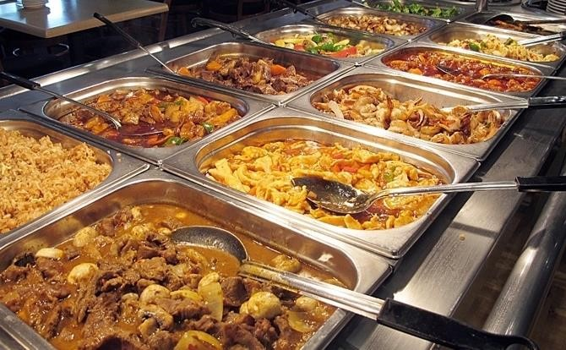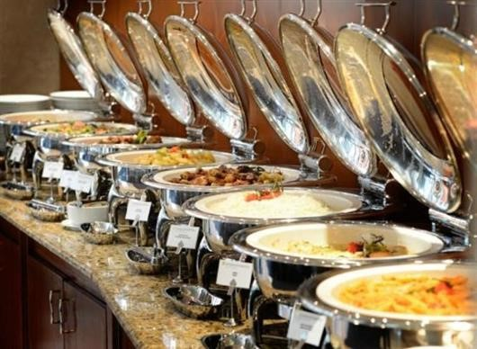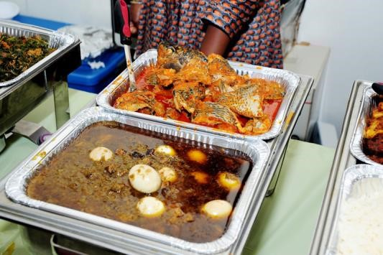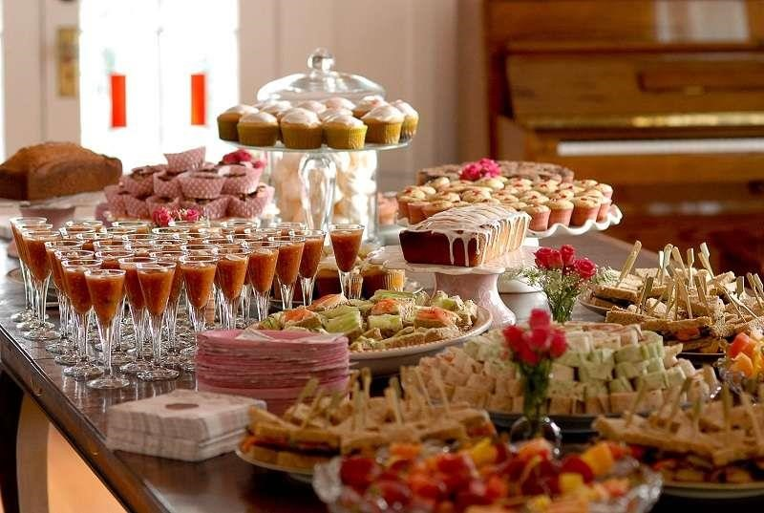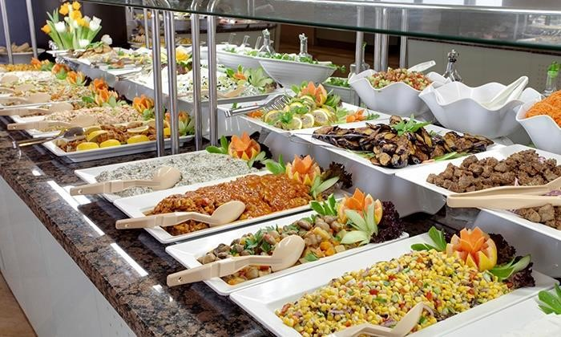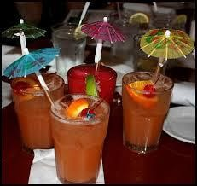

**CONCLUSION**



Intercontinental Menus

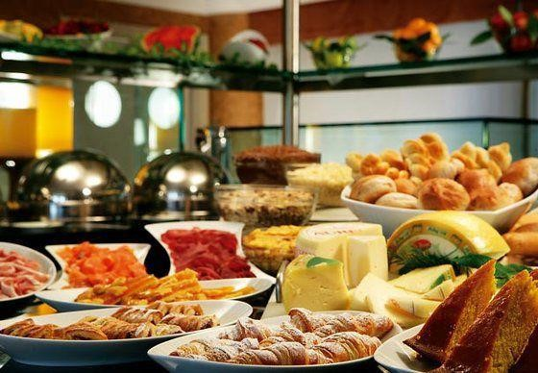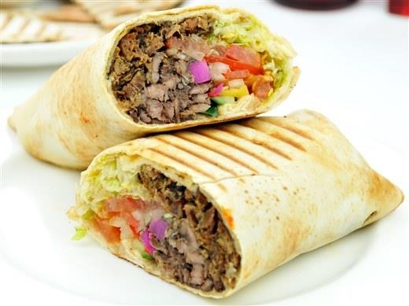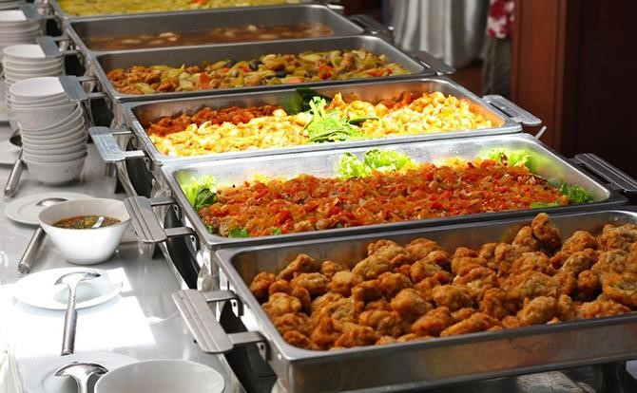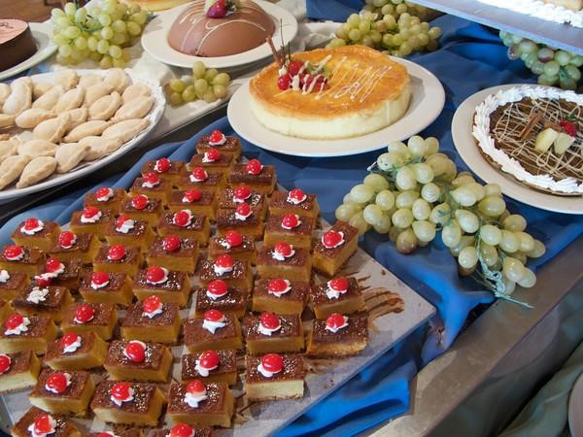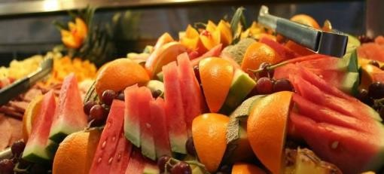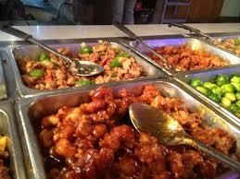

We place a high premium on value. We have designed a price structure that is differentiated to accommodate various levels of affordability. We however, passionate to provide great food and commitment to excellence. Partner with us today and you will never regret the experience.

HOW CAN WE SERVE YOU?

Unique Spicy Event& Catering Services

**uniquespicyevents@gmail.com**

## +234 802 760 0945 / 806 055 4409